Part A:

Look at the picture of vegetables below. Which vegetables are your favourites? And which ones do you hate? Share your feelings and ideas with your teacher and classmates (“I like ………. and ……. because ………, but I hate ……… and ……. because ……….”):
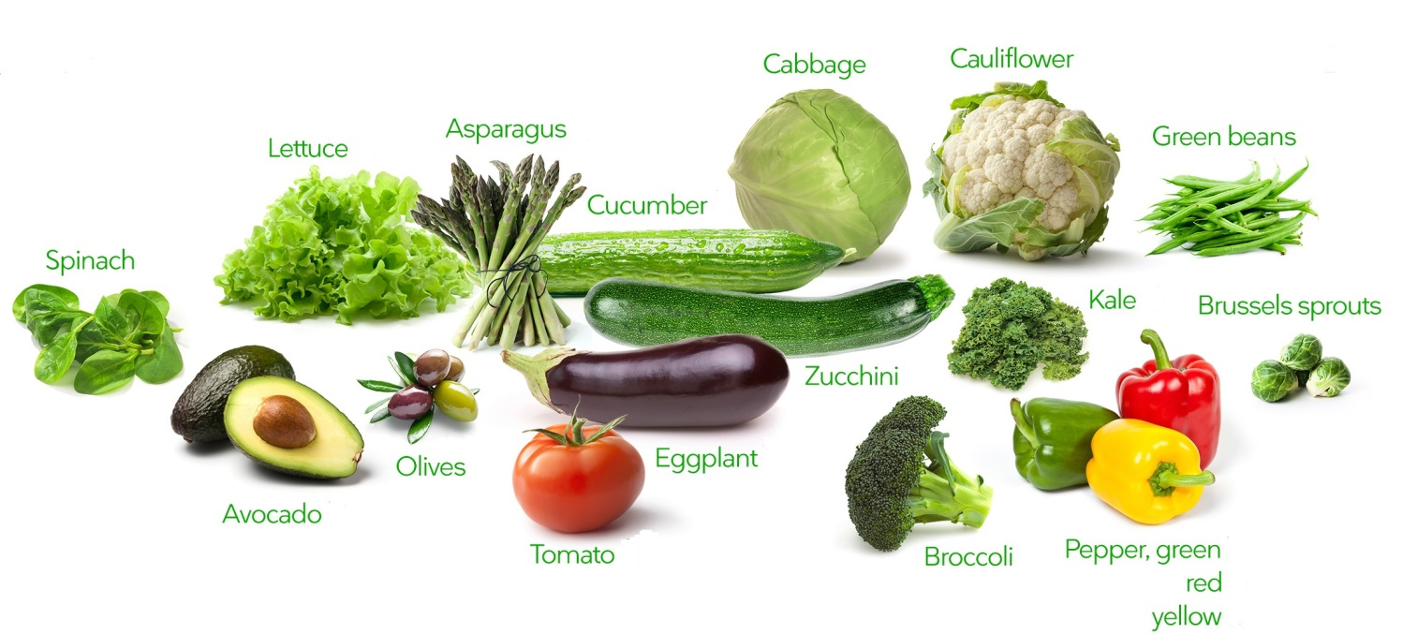


The woman in the picture is holding a vegetable. What do you think she is holding?

Do you like vegetables with a bad smell? Which one is more important for you: their bad smell or their benefits for health? Why?

GARLIC
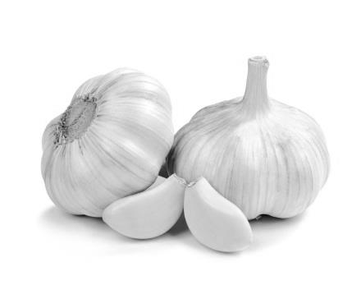
(1) Some people can’t stand garlic. “That smell! It’s too strong. And it doesn’t go away! There is nothing worse than garlic.” they say. Other people say garlic tastes great and it’s good for you, too. Chester Aeron grows eighty-seven kinds of garlic on his farm. He wrote a book called Garlic is Life. It seems that people either love garlic or hate it.
(2) Garlic has a long history. The first wild garlic probably grew somewhere in western Russia. People in that area found it and learned to use it. Later, travellers carried garlic with them to China, India, Europe and North Africa. Farmers began planting it over 5,000 years ago. They grew garlic to eat and used it as medicine when they were sick. They also grew it for use in religious ceremonies.
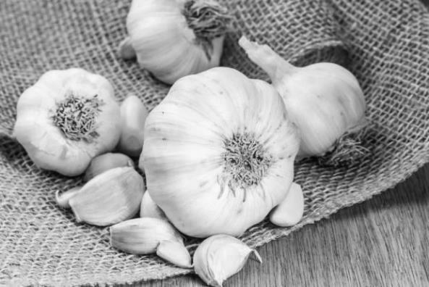
(3) People in many cultures shared similar ideas about garlic. For example, they made their slaves eat it. They believed garlic made it possible for slaves to work harder and longer. In Greece, the athletes of the first Olympic Games ate garlic. They wanted to become stronger and faster, and they believed that garlic would help. Soldiers in the Roman army ate garlic, too. They ate it to help them fight better. But garlic wasn’t only for slaves, athletes, and soldiers. In some places, garlic was called “food for lovers.”
(4) People had even more uses for garlic. They added it to other foods because it tasted good. In China, people also used garlic to keep meat fresh. The Chinese were probably the first people to write about the uses of garlic. They wrote about it 4,000 years ago.

(5) People in many cultures ate garlic when they got sick. It was thought to make a cold or fever go away. It was also supposed to help with different kinds of pain – for example, when someone’s head, ear, or muscles hurt.
(6) Is eating garlic actually good for you, or should we just laugh at these old ideas? The truth is, doctors today are telling their patients, “eat garlic!” Recent research shows that garlic is good for your heart. It turns out that garlic helps people stay healthy.

(7) However, we can’t accept every idea about garlic from the past. In many cultures, people trusted garlic to protect them from all kinds of bad luck. Garlic is great, but it can’t do that! Also, don’t tie garlic around your neck. It won’t keep vampires away, as people used to think. It would probably just keep your friends away.

Part B: Match the paragraphs in Column A with the main ideas in Column B. There is ONE EXTRA main idea in Column B.

COLUMN A | COLUMN B
Paragraph 1 _____ | - Eating garlic to become physically better
Paragraph 2 _____ | B. Results of current scientific studies on benefits of garlic
Paragraph 3 _____ | C. Old ideas about using garlic to stop misfortune
Paragraph 4 _____ | D. Different feelings of people about garlic
Paragraph 5 _____ | E. The harms of eating too much garlic
Paragraph 6 _____ | F. Eating garlic to become healthy again
Paragraph 7 _____ | G. Origins of garlic
 | H. Using garlic while cooking

Part C: Answer the following questions according to the text.

- We can understand from paragraph 1 that _______.
- most people love garlic but only a few people hate it
- there are many types of garlic
- Chester Aeron wrote a book to tell people why he hates garlic
- some people hate garlic because it makes them sick

- Which one is false according to paragraph 2?
- The history of garlic goes back to a very long time ago.
- People in Russia first discovered garlic.
- Some people on journey took garlic from Russia to many different countries.
- People used garlic only to eat it after they started planting it.

- Which one is false according to paragraph 3?
- Slaves ate garlic because people thought garlic made them stronger.
- Athletes ate garlic because they thought garlic made them faster.
- Soldiers ate garlic because they thought garlic made them a better soldier.
- Lovers ate garlic because they thought garlic made them smell better.

- We can understand from paragraph 4 that the Chinese _______.
- first started eating garlic 5,000 years ago
- never used garlic when they cooked their meals
- first mentioned the uses of garlic on paper
- ate meat with garlic because it tasted good

- We can understand from paragraphs 5 and 6 that garlic is good for your _______.
- psychology
- body
- budget
- diet

- According to paragraph 7, people _______.
- should be careful of the old beliefs about the magical powers of garlic
- believed in the past that garlic brought bad luck, so they never used it in their meals
- should put garlic on their neck because it smells very good
- can use garlic to fight against vampires because vampires hate the smell of garlic

- The purpose of the text is _______.
- to warn people about the dangers of garlic
- to persuade people to use garlic in their food
- to inform people about the history of garlic and its different uses for food and health
- to educate people about the best ways of using garlic in the kitchen

Part D: Guess the meaning of the words.

- Find the word in paragraph 1 which means ‘to tolerate, to bear’: _____________
- Find the word in paragraph 2 which means ‘possibly, perhaps’: _____________
- Find the word in paragraph 6 which means ‘study, inquiry, experiment’: _____________
- Find the word in paragraph 7 which means ‘to agree, to approve’: _____________
- Find the word in paragraph 7 which means ‘to believe, to depend on’: _____________

Part E: What do the words refer to?

- The word ‘them’ in paragraph 2 refers to ________.
- farmers b) travelers c) Russian people d) Chinese people

- The word ‘They’ in paragraph 3 refers to ________.
- slaves b) soldiers c) lovers d) athletes

- The word ‘it’ in paragraph 4 refers to ________.
- garlic b) meat c) use d) food

- The word ‘their’ in paragraph 6 refers to ________.
- people’s b) doctors’ c) doctors d) people

- The word ‘them’ in paragraph 7 refers to ________.
- people b) vampires c) cultures d) friends


Part F: Role-Play
Scenario: Student A is a doctor and Student B is a patient. Student B (the patient) has some health problems and visits Student A (the doctor). Student A thinks that Student B should eat garlic everyday but Student B does not like the advice. So, Student A tries to persuade Student B.

Work with a partner and write a dialogue first and then act it out in front of your friends.
STUDENT B
- You are the patient.
- Talk about your health problems and ask for advice from your doctor.
- Tell your doctor how you feel about garlic.
- Garlic does not taste good.
- Garlic smells bad.
- Your work in a crowded office.
- Ask your doctor why you need garlic.
- Learn more about the benefits of garlic from your doctor.
- Tell your doctor about your decision.

STUDENT A
- You are the doctor.
- Persuade your patient to eat garlic everyday.
- Talk about the health benefits of garlic.

Some benefits of garlic:
- Garlic controls sugar levels.
- Garlic helps digestion.
- Garlic reduces weight.
- Garlic stops cancer.
- Garlic is a natural aphrodisiac

Doctor: Can you tell me about your problem?
Patient: Of course. I have several health problems. I have high sugar level and ...........................
......................................................................................................................................................................
Doctor: .......................................................................................................................................................
Patient: .......................................................................................................................................................
Doctor: .......................................................................................................................................................
Patient: .......................................................................................................................................................
Doctor: .......................................................................................................................................................
Doctor: .......................................................................................................................................................
Patient: .......................................................................................................................................................
Doctor: .......................................................................................................................................................
Patient: .......................................................................................................................................................
Doctor: .......................................................................................................................................................
Patient: Thank you for all this information. Have a nice day!

